System Parameter FGMaster

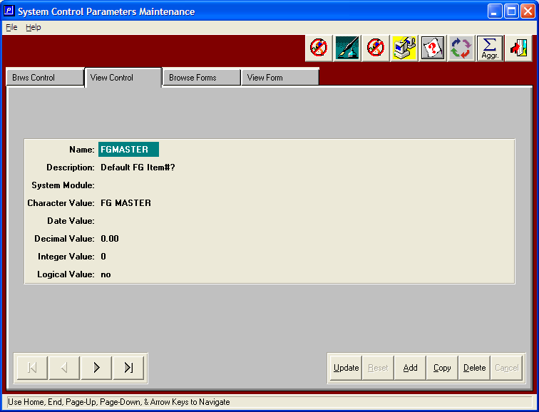

N-K FGMASTER will use the finished goods item code that will be used for default fields when creating finished goods items via order entry or via the ADD button in finished goods. The new item will copy the fields such as Product Category, Ship Method, Inventory Class, Selling UOM, Cost UOM, Currency, Warehouse, Bin, Purchased or Manufactured, Stocked, Active, Cycle Count Code, Production Code, Taxable, Vendor Code1, Vendor Code 2, Reorder Policy, Assembled or Unassembled and Freight Classification.

Character Value: Set the character value to an item that will serve as a MASTER finished goods item when creating a new finished goods item record.

Please note, this works similar to the customer X logic when adding new customers.

